# SANJALIKA WATERPARK SLIDE’S DESCRIPTION WITH MORE FEATURES

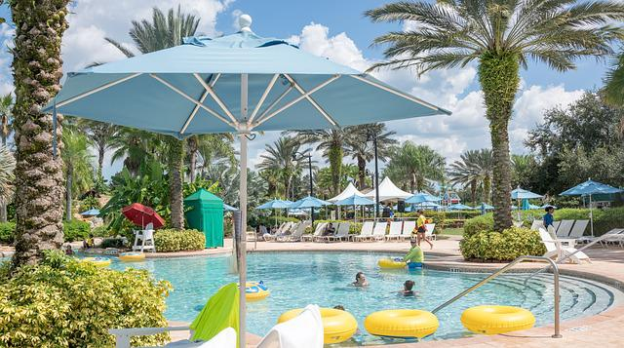

Figure sanjalika waterpark

Sanjalika Water Park is definitely an ultimate and out of the world source of entertainment. Decorated by mermaids, other statues, the Sanjalika Water park has largest cave and swimming pool area of modern technology a kind of place for thrills and fun. At Sanjalika Water park there is lot of water rides which are very exciting and thrilling.

In this document, you are gonna learn about more features of the slides with their information.

BOOMERANG SLIDE

Water parks are amusement parks that consist of lots of slides, playgrounds, swimming pools and lots of other areas which are full of water but are covered with various roundabouts. Water parks are mostly the favorite place to visit for every child and a lot of families during the summer visit various water parks as well. There are a lot of famous water parks around the world, and here a few of those water parks would be discussed where one can enjoy a **water park picnic** with his family.

FEATURES OF THE BOOMERANG SLIDE

●for 4 persons playing at most  
● used for indoor and outdoor hotel, theme park, etc.  
●suitable for family play  
● Use top material to make sure the safety and steady of water slide  
  
Boomerang slide is one of the most popular large-scale water slides, and every raft can supply four seats at the same time. The tower height can range from 9m to 18.5m and length can reach 106m. With the influence of gravity, when taking a raft from the 12.5m high platform and slipping on the slide rapidly, guests will have the feeling of weightlessness. Then under the effect of inertia, they rush across the slide and slip down the pool slowly. Furthermore, we also supply Boomerang with spiral slides which can bring more surprises to guests. You can slide down one by one under the lubrication of water and gravity through the spiral entrance and steep slide. Visitors will experience a wonderful feeling during the journey.

MORE FEATURES

|  |  |
| --- | --- |
| **Width** | 2.5m-6.5m |
| **Capacity** | 4person/raft |
| **Platform height** | 12.5m |
| **Floor space** | 23m×60m |
| **Mats** | No |
| **Tubes** | No |
| **Rafts** | Yes |
| **Production Method** | RTM |
| **Width** | 2.5m-6.5m |

BOOMERANG SLIDE IMAGES

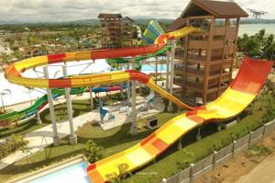

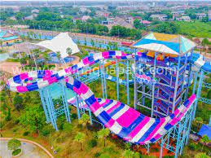

And many more images, customer feedback on such slides have always been good and keeps getting better.

Thank you!